**5.1 Mechanisms of Hormone Action\***

* Gland = organ that secretes hormones

Classification of Hormones by Chemical Structure

* Mnemonic
  + Peptide and amino acid-derivative hormones → ***-in*** or ***-ine***
    - E.g. insul***in***, vasopress***in***, thyrox***ine***, triiodothyron***ine***
  + Steroid hormones → ***-one***, ***-ol***, ***-one***, or ***-oid***
    - E.g. testoster***one***, aldoster***one*** and other mineralocortic***oid***s, cortis***ol*** and other glucocortic***oids***

1. Peptide Hormones
   1. Made up of amino acids derived from larger precursor polypeptides → smaller units modified by Golgi apparatus
   2. **Hydrophilic** (first messenger) → binds to surface receptors → second messenger e.g. cAMP, IP3 → signalling cascade
   3. Effects are **rapid and short-lived** because they act through transient second messenger systems
   4. **Water-soluble** → can travel freely in the bloodstream → do not require carriers
2. Steroid Hormones
   1. Derived from **cholesterol**, and are produced primarily by the gonads and adrenal cortex
   2. **Hydrophobic** → binds to intracellular or intranuclear receptors → conformational change (e.g. estrogen causing dimerization) → **binds directly to DNA** → affects gene expression
   3. Effects are **slow but long-lived** because they cause alterations in the amount of mRNA and protein
   4. **Not water-soluble** → must be carried by proteins in the bloodstream e.g. TBG
3. Amino Acid-Derivative Hormones
   1. Derived from one or two amino acids, usually with a few modifications

Classification of Hormones by Target Tissue

1. Direct hormones
   1. Secreted and act directly on a target tissue
   2. E.g. insulin by pancreas → muscle
2. Tropic hormones
   1. Stimulate the production of another hormone by another endocrine gland that acts on distant tissues
   2. Usually originate in the brain and the anterior pituitary gland
   3. E.g. GnRH from hypothalamus → LH and FSH → ...

**5.2 Endocrine Organs and Hormones**

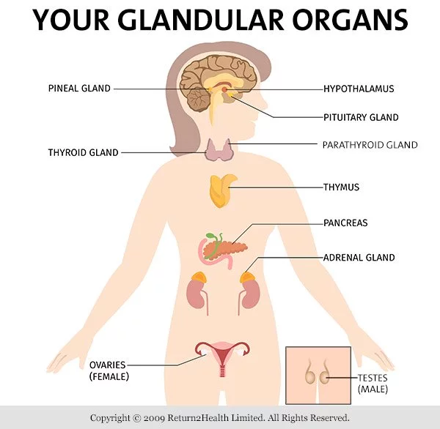

Hypothalamus

* Hypophyseal portal system → blood vessel directly connecting hypothalamus with the anterior pituitary
* Hypophysis = pituitary

Tropic hormones (hypothalamus → anterior pituitary)

1. Gonadotropin-releasing hormone (GnRH) → follicle-stimulating hormone (FSH) and luteinizing hormone (LH)
2. Growth hormone-releasing hormone (GHRH) → growth hormone (GH)
3. Thyroid-releasing hormone (TRH) → thyroid-stimulating hormone (TSH)
4. Corticotropin-releasing hormone (CRF) → adrenocorticotropic hormone (ACTH)

Non-tropic hormone

1. Prolactin-inhibiting factor (PIF), which is dopamine → decrease in prolactin (PRL) secretion

Interactions with the Posterior Pituitary

* Neurons in the hypothalamus send their axons down the pituitary stalk directly into the posterior pituitary (not tropic hormones!), which can then release:

1. Oxytocin → stimulates uterine contractions during labor + milk letdown during lactation
2. ADH (or vasopressin) → increases reabsorption of water in the collecting ducts of the kidneys

Anterior Pituitary

* FLATPEG

Tropic hormones

1. FSH → gonads
2. LH → gonads
3. ACTH → adrenal cortex
4. TSH → thyroid

Direct hormones

1. PRL → stimulates milk production in the mammary glands
2. Endorphins → decrease perception of pain
3. GH → promotes the growth of bone and muscle
   1. By preventing glucose uptake in tissues that are not growing + stimulating the breakdown of fatty acids → increases overall glucose availability

Posterior Pituitary

1. ADH is secreted in response to:
   1. Low blood volume (baroreceptors)
   2. Increased blood osmolarity (osmoreceptors)

→ increases permeability of the duct to water → greater reabsorption of water

1. Oxytocin is secreted during childbirth → uterine contraction + milk letdown
   1. Positive feedback loop

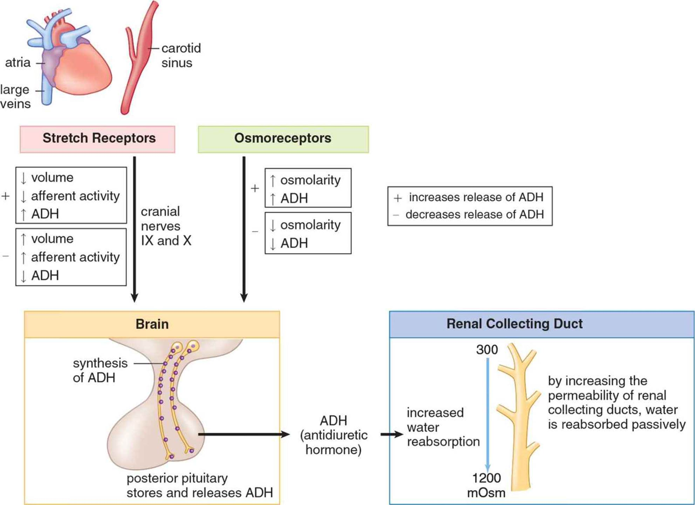

Thyroid

1. Triiodothyronine (T3) and Thyroxine (T4)
   1. Produced by the iodination of the amino acid tyrosine in the **follicular** cells of the thyroid → the numbers refer to the number of iodine atoms attached
   2. More T3 and T4 → increased cellular respiration → speed up both synthesis and degradation of protein and fatty acid → more turnover → makes energy production more efficient → **increase metabolic rate of the body**
   3. Deficiency in iodine or inflammation of the thyroid→ little or no thyroid hormones released → hypothyroidism → decreased metabolism and weight gain
   4. Excess of thyroid hormone (due to tumor or thyroid overstimulation) → hyperthyroidism
2. Calci**ton**in
   1. Produced by C-cells (parafollicular cells)
   2. Calci**ton**in → **ton**es down blood calcium levels
      1. Increased calcium excretion from the kidneys
      2. Decreased calcium absorption from the gut
      3. Increased storage of calcium in the bone

Parathyroid Glands

1. Parathyroid hormone (PTH)
   1. **Antagonistic to calcitonin**
   2. PTH → **increases blood calcium levels**
      1. Decreased calcium excretion from the kidneys
      2. Increased calcium absorption in the gut (via **Vitamin D**)
      3. Increases bone resorption → more free calcium
   3. Little effect on phosphate (following effects cancel out)
      1. Resorbs phosphate from bone → more phosphate in blood
      2. Reduces reabsorption of phosphate in the kidney → more phosphate excreted

Adrenal Cortex

* Adrenal glands located on top of the kidneys (Ad- renal → near kidney)
  + Cortex → **corticosteroids**
    - **S**ugar (glucocorticoids)
    - **S**alt (mineralocorticoids)
    - **S**ex (cortical sex hormones)
  + Medulla → epinephrine and norepinephrine
    - Fight-or-flight response
* More CRF from hypothalamus → more ACTH from the anterior pituitary → more corticosteroids from adrenal cortex

1. Glucocorticoids → affect glucose levels and protein synthesis
   1. Cortisol and Cortisone
      1. Increase gluconeogenesis + decrease protein synthesis → **increase blood glucose**
      2. Decrease inflammation and immunological response
   2. Cortisol only
      1. Stress hormone → **increase blood sugar in times of stress**
2. Mineralocorticoids → salt and water homeostasis
   1. Aldosterone → **only increases plasma volume, NOT blood osmolarity** (which is done by ADH)

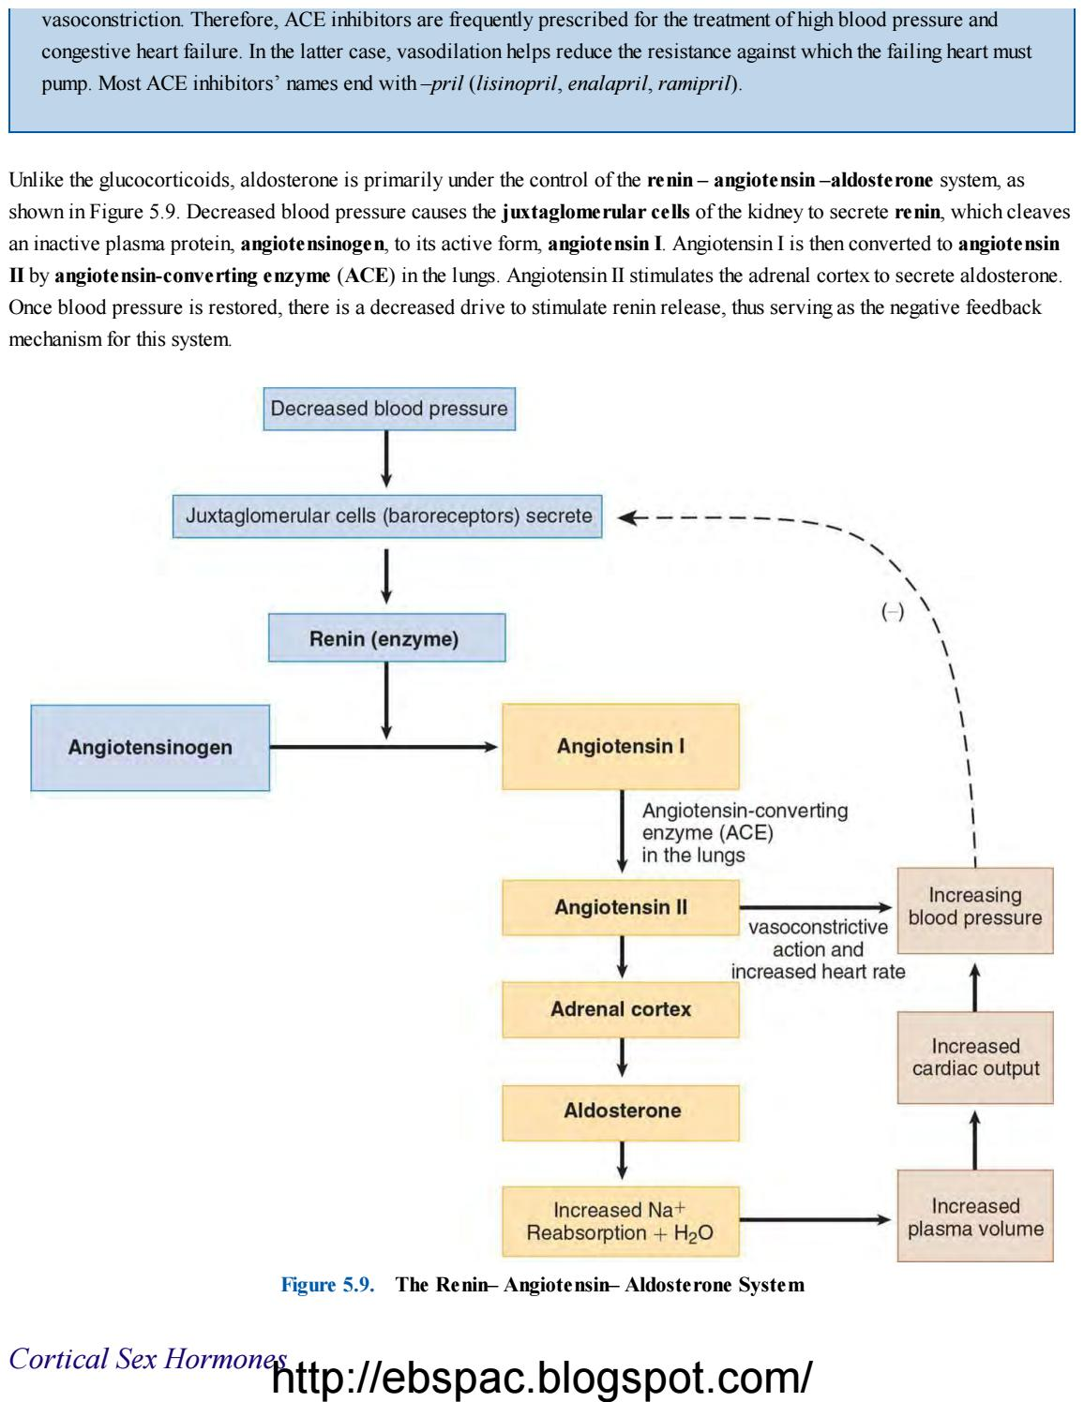

1. Cortical Sex Hormones
   1. **Androgens and estrogens**
   2. Males less affected by adrenal testosterone
      1. Testes already secrete large amounts of androgens
      2. Males can however be affected by excessive production of estrogens
   3. Females more sensitive to disorders of cortical sex hormone production
      1. Certain enzyme deficiencies during synthesis → excess CSH → a genotypic female may be born with ambiguous or masculinized genitalia (males do not have obvious phenotypic effects)

Adrenal Medulla

* Produce sympathetic hormones, epinephrine and norepinephrine (catecholamines) → **fight-or-flight response**

1. Epinephrine only
   1. **Increases glycogenolysis** (glycogen → glucose) in liver and muscle
   2. Increases basal metabolic rate
2. Epinephrine and norepinephrine → **increases heart rate, dilate the bronchi**
   1. Vasodilation of blood vessels leading to skeletal muscle, heart, lungs, and brain
   2. Vasoconstriction of blood vessels leading to gut, kidneys, skin

Pancreas

* **Exocrine** function → secrete substances e.g. **digestive enzymes** directly into **ducts** (then duodenum)
* **Endocrine** function → secrete **hormones** into **bloodstream**

**Islets of Langerhans cells** (throughout the pancreas)

1. Alpha cells
   1. **Glucagon** (produced when **glucose levels are low**) stimulates:
      1. Degradation of protein and fat
      2. Conversion of glycogen to glucose
      3. Production of new glucose via gluconeogenesis
   2. Gastrointestinal hormones e.g. **cholecystokinin** and **gastrin** can also increase glucagon release
2. Beta cells
   1. **Insulin** (produced when **glucose levels are high**):
      1. Induces muscle and liver cells to take up glucose and store it as glycogen for later use
      2. Stimulates anabolic processes e.g. fat and protein synthesis
   2. Antagonistic action to glucagon
3. Delta cells
   1. **Somatostatin** (produced when glucose and amino acid concentrations are high):
      1. Inhibits insulin and glucagon secretion
      2. Also produced by the hypothalamus → decreases GH secretion

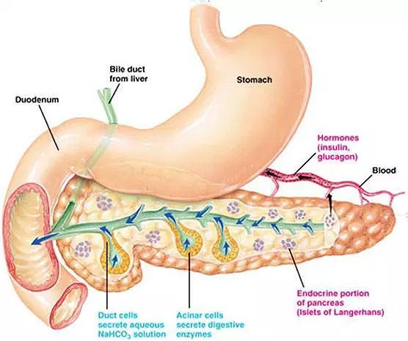

Gonads

* Testosterone, estrogen and progesterone secreted in response to stimulation by gonadotropins (FSH and LH)

1. Testosterone (in testes)
   1. Sexual differentiation of the male during gestation
   2. Development of secondary sex characteristics
2. Estrogen and progesterone (in ovaries)
   1. Development of the female reproductive system during gestation
   2. Development of secondary sex characteristics
   3. Govern the menstrual cycle and pregnancy

Pineal Gland

* Located deep within the brain

1. Melatonin
   1. Involved in circadian rhythms (mechanism unclear)
   2. Partially responsible for the sensation of sleepiness

Other Organs

1. Gastrointestinal peptides (stimulus for release is the presence of specific nutrients)
   1. Secretin
   2. Gastrin
   3. Cholecystokinin
2. Kidneys
   1. **ADH increases water permeability (reabsorption) in the collecting duct**
   2. **Renin-angiotensin-aldosterone system increases sodium and water reabsorption in the distal convoluted tubule and collecting duct**
   3. Produce **erythropoietin** (when blood oxygen levels are low) → stimulates bone marrow to increase production of erythrocytes
3. Heart
   1. Releases atrial natriuretic peptide (**ANP**) (when cells in the atria are stretched from excess blood volume) → promotes excretion of sodium and therefore increases urine volume
      1. Functionally **antagonistic to aldosterone** because it **lowers blood volume and pressure, and has no effect on blood osmolarity**
4. Thymus (located directly behind the sternum)
   1. Releases **thymosin** → proper T-cell development and differentiation
      1. By adulthood, the thymus atrophies → thymosin levels drop accordingly